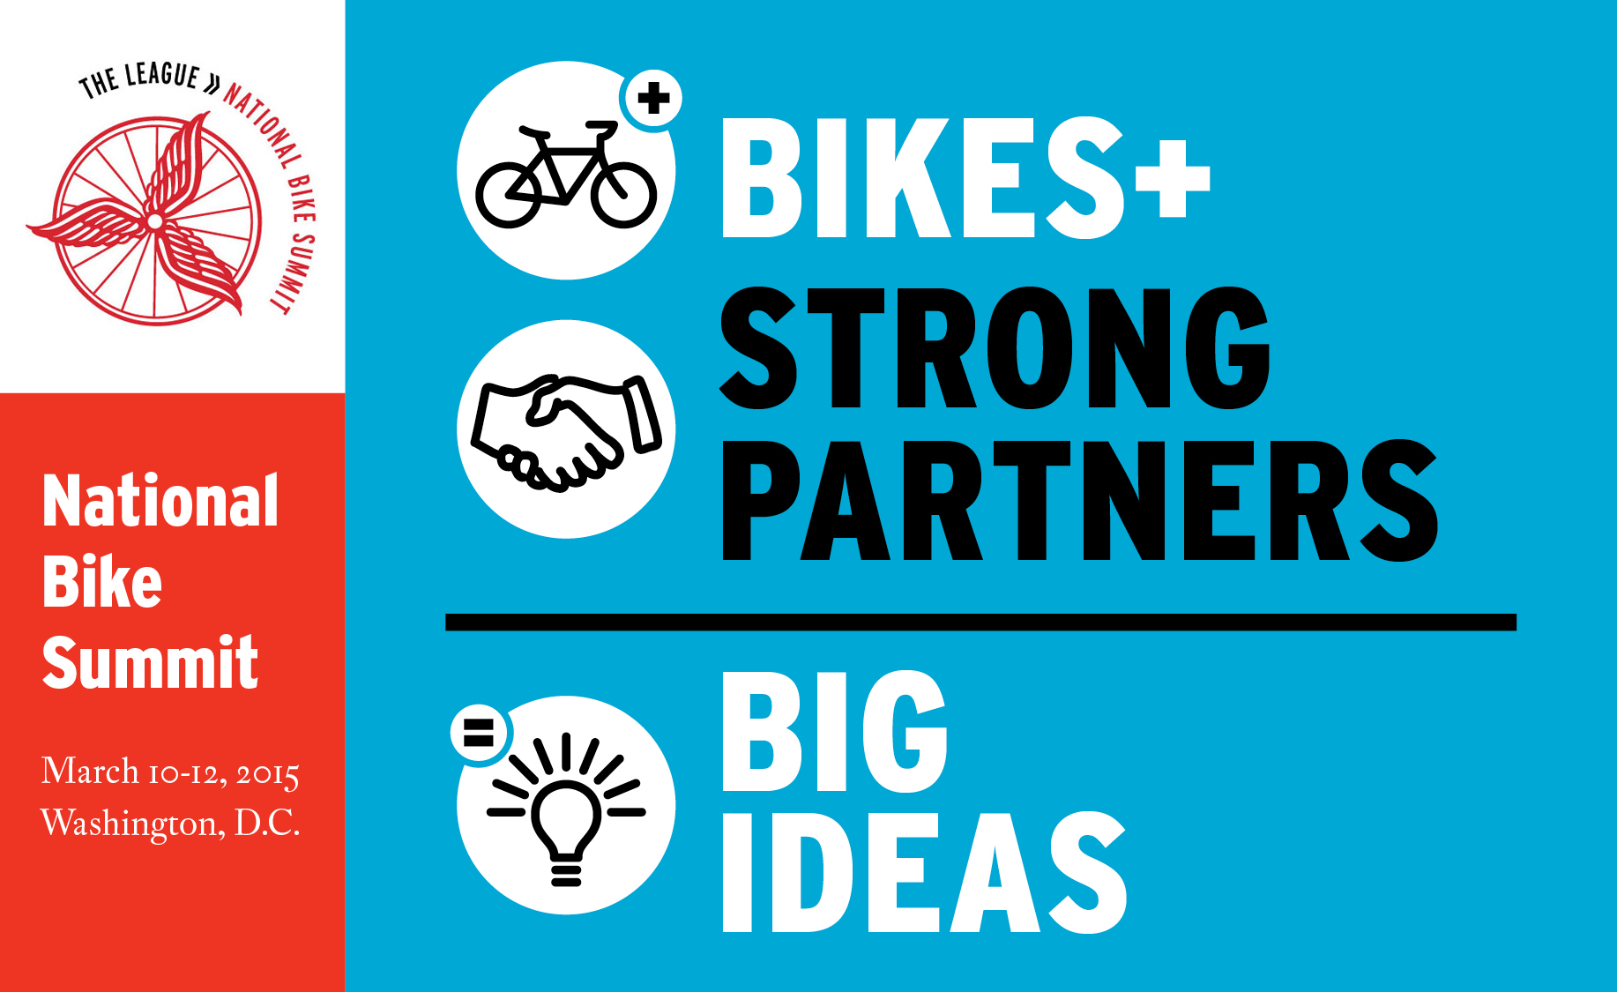

#TODAY#

Dear #CONGRESSMAN#,

National Bike Summit participants from your #REGION# will be coming to Washington, DC, on Thursday, March 12th as part of the National Bike Summit in Washington, D.C., and would like to take the opportunity to meet with you. The #PL_CONSTITUENT# from your #REGION# who will be participating in the meeting #PL_IS#:

#CONSTITUENTS#

We hope you would be available to meet sometime between 9:00 am and 5:00 pm on Thursday, March 12th.

Our members would like to meet with you to discuss the benefits bicycling and walking bring to the community, and why it is important to ensure the next transportation bill improves safety and access to bicycling for everyone.

These individuals play an important role in creating and sustaining the great communities in your District. Although we understand your busy schedule, we hope you can spare a few minutes to talk with them about ways in which the federal government can improve and enhance its partnership with these individuals and the communities they represent. If you are unavailable, we hope a legislative assistant dealing with transportation will be able to meet with these constituents.

Thank you for your attention in this matter. We will contact you in the next few days to see what may be possible.

Thank you!

#YOUR NAME#

