Federal Lands Access Program (FLAP)
Advocacy Guide
The Federal Lands Access Program (FLAP) is a new funding source under the federal transportation bill, MAP-21, for which bicycle and pedestrian projects connecting to public lands are eligible. For more detailed information on this program, download the FLAP Fact Sheet: www.advocacyadvance.org/site_images/content/FLAP_combined(1).pdf
A new funding program for biking and walking
- $250 million is authorized per year, a portion of which can be used to support trails and bike/ped planning and facilities.
- Recipients of FLAP funding are state and local agencies and not federal land agencies.
- Planning and construction activities are eligible.
- Federal high-use areas and economic generators are given preference.
- Most states require a 20% match.
State level decision-making
- Eighty percent of the funding from this program will be distributed to 12 western states leaving $50M /year to be divided among the other 38 states (see Appendix I).
- Each state has a unique decision-making process. See state-specific funding amounts and application information: www.advocacyadvance.org/site_images/content/FLAP_state.pdf
- Bicycle and pedestrian projects will compete with eligible bridge and highway projects. Funded projects must be on the State Transportation Improvement Program (STIP).
- Funding requires broad collaboration and support.
Nothing ventured; much to lose
- Use this as an opportunity to engage your federal lands manager in a discussion of improved bike/ped access.
- Contact your FHWA regional program administrator (Appendix I) to demonstrate interest in biking and walking projects, not just roads.
- As a new and small program, FLAP may provide opportunities to be creative.
Getting started
- Start by meeting with federal land managers – they may have projects in mind.
- Call your state FLAP contacts to find deadlines and process. See state-specific information: www.advocacyadvance.org/site_images/content/FLAP_state.pdf
- Get letters of support from elected officials and community partners (Appendix II).
- If the application deadline has passed for your state, spread the word about this program since funding will also be available in 2014.
Advocacy Story: Teton Pass Centennial Trail (Wyoming Pathways)
- Advocates researched MAP-21 and analyzed Federal Lands programs.
- Wyoming Pathways and Teton Valley Trails and Pathways organized citizen support committee, developed initial FLAP Grant concept.
- Initial meetings with Forest Service Land Manager for by-in, support.
- Meetings with project sponsors and discussions on Match source; nonprofits pledged to assist with match and maintenance.
- Field visits, cost estimates, project development – Advocates organized and agencies attended.
- Advocates helped write and edit the grant applications for local sponsors.
- Advocates drafted and secured support letters.

- Small projects and plans may find an opportunity for funding – this would be the first step towards a bigger vision.
Role of Advocacy Organizations for FLAP Projects
- Prepare photo simulations for concept development.
- Assist with cost estimates.
- Prepare maps and exhibits.
- Generate strong community support to help secure project sponsors.
- Assist with media efforts.
- Solve problems and issues creatively.
What to do if Your States’ Deadline Has Passed?
- Start getting ready for next year.
- Learn the program details, identify your top project that will be competitive.
- Start to build community support.
- Meet with the land manager and secure commitment to seek grant.
- Be a watchdog for the FLAP process in your state – be vigilant!

Additional Tips from Previous Applicants
- Each state is different: ask explicit questions about eligibility and definitions
- Ask for the definition of “economic generator” (e.g. does this mean a federal high use area?)
- Consider differences between state, regional and local decision-makers and potential concerns for each
- Work through the details with partners who “own or maintain” the land
- Remember that “supporters” and “doers” may be different people
- Don’t ask for too much of the total funding pot; expect competition
- Keep the proposal short and address potential concerns at the beginning
- Ensure the Program Decision Committee members for your state understand the proposal
- Act now! Some states may not have another call for projects for two or three more years. If your state’s deadline has passed, make sure agencies know there is demand for future funding.
Appendix I
FHWA Regional Program Administrators
For state-by-state distribution, timelines and contacts: www.advocacyadvance.org/site_images/content/FLAP_state.pdf
Federal Lands Headquarters (Washington, DC)
Frances Ramirez, 202-493-0271 Frances.Ramirez@dot.gov

Western Federal Lands Office (Vanouver, WA)
FHWA WFL FLAP Coordinator: Tom Erkert, 360-619-7791 Tom.Erkert@dot.gov

Central Federal Lands Office (Lakewood, CO)
FHWA CFL FLAP Coordinator: Allen Grasmick, Allen.Grasmick@dot.gov, (720) 963-3664

Eastern Federal Lands Office (Sterling, VA)
FHWA EFL FLAP Coordinator: David Payne, David.Payne@dot.gov (571) 434-1543

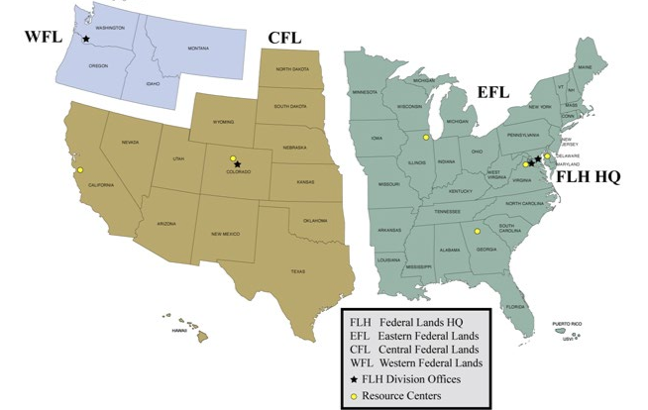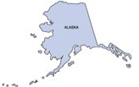

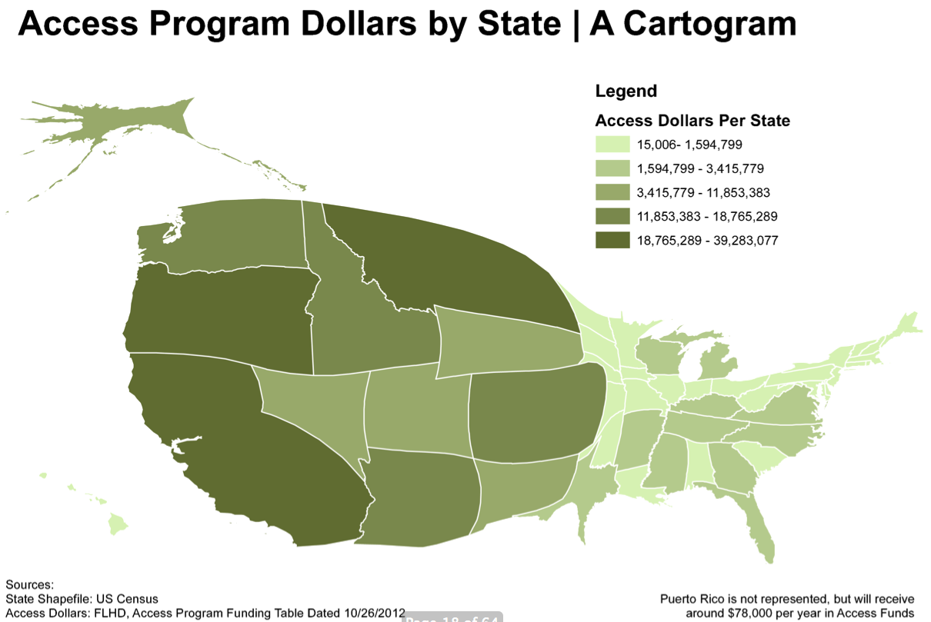
Appendix II
Sample Letter of Support (Adventure Cycling)
